**Screenshots:**

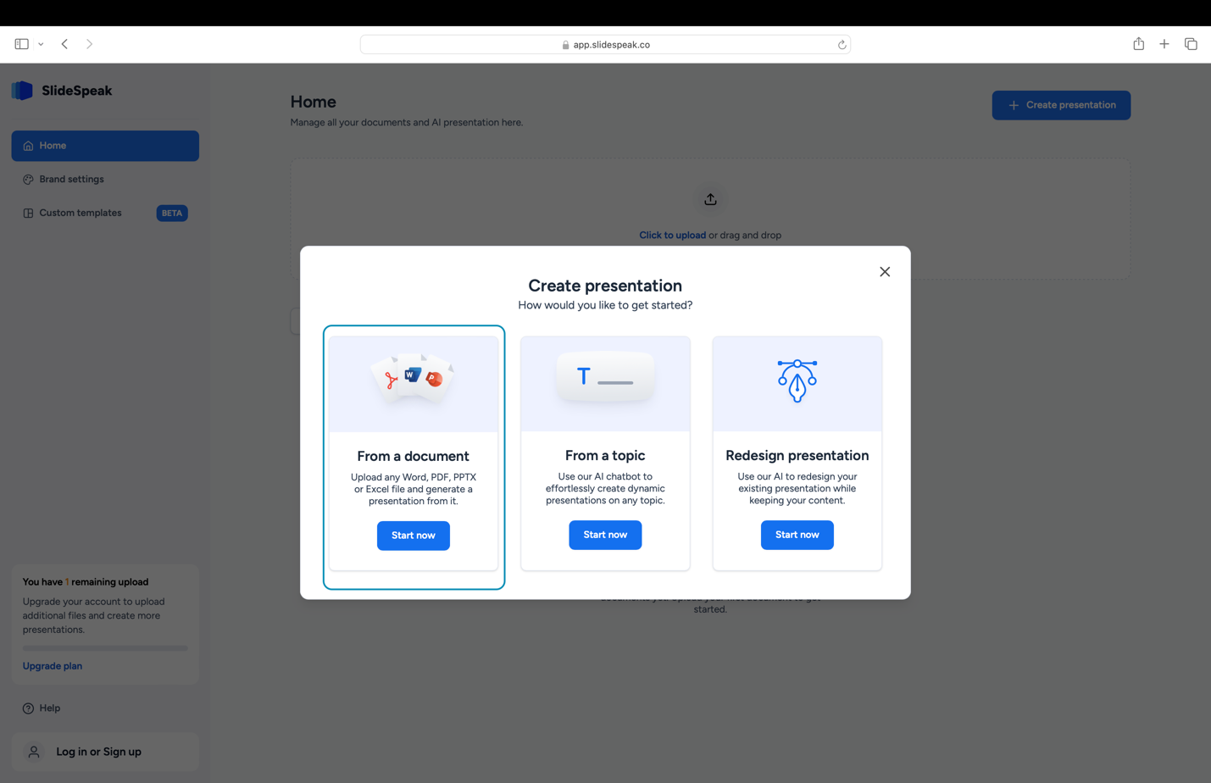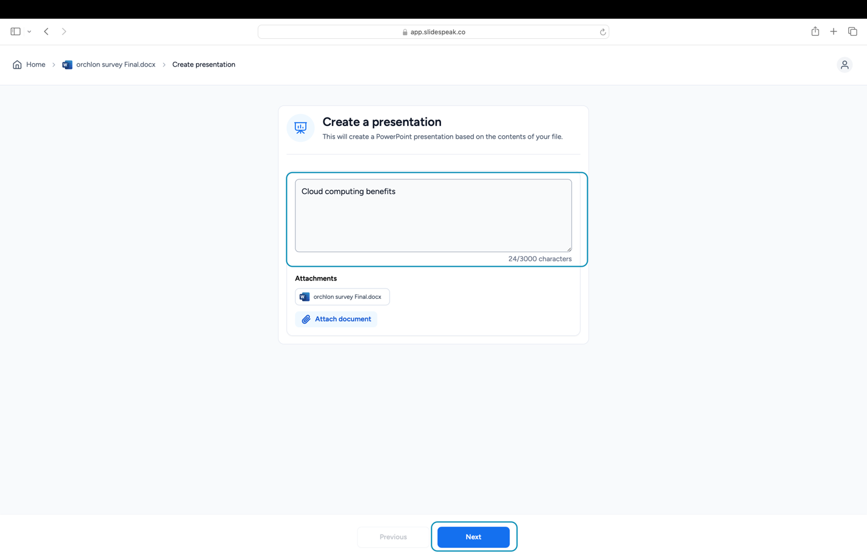

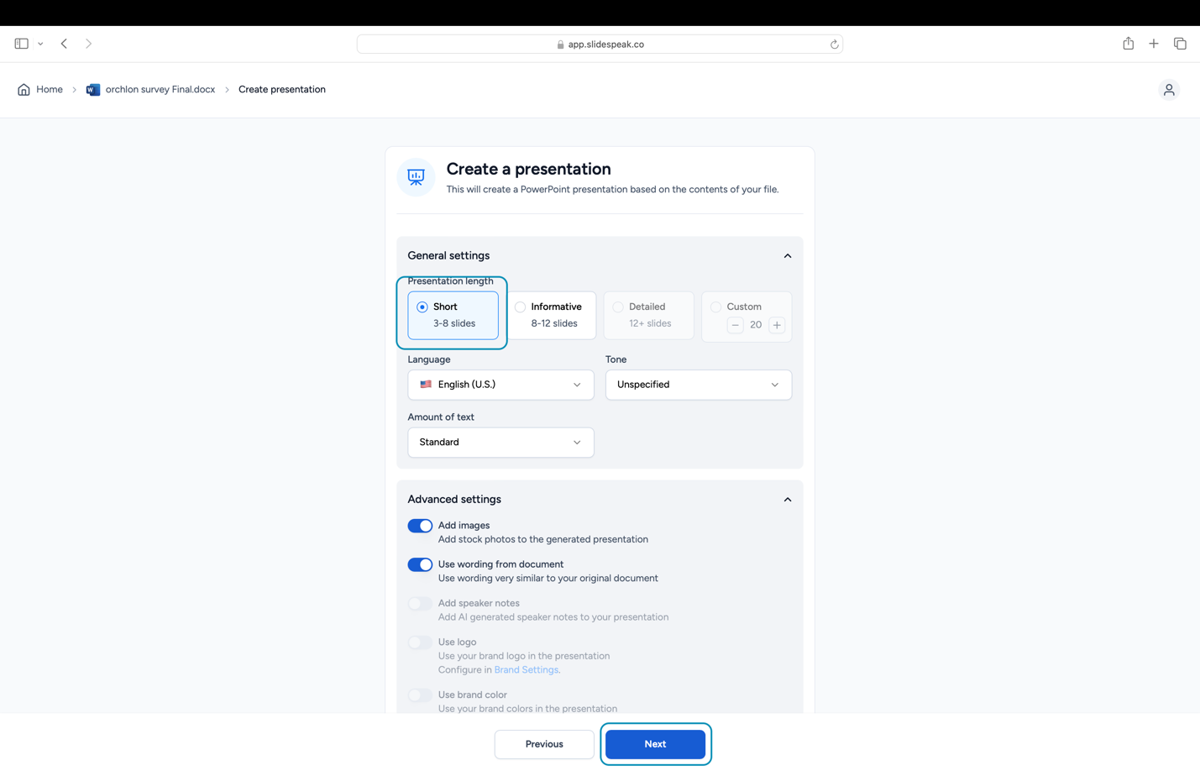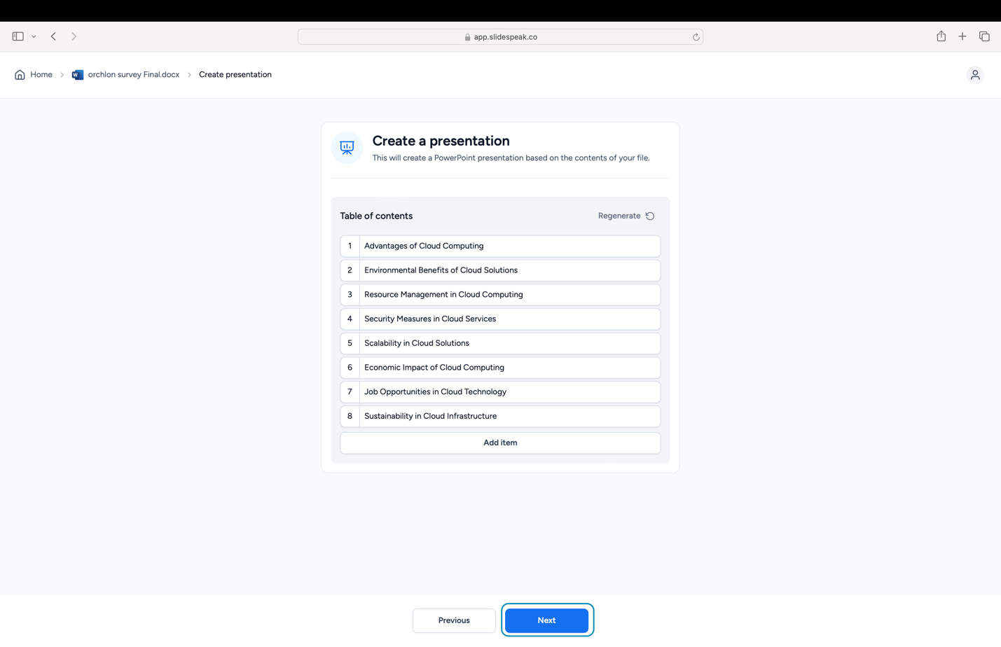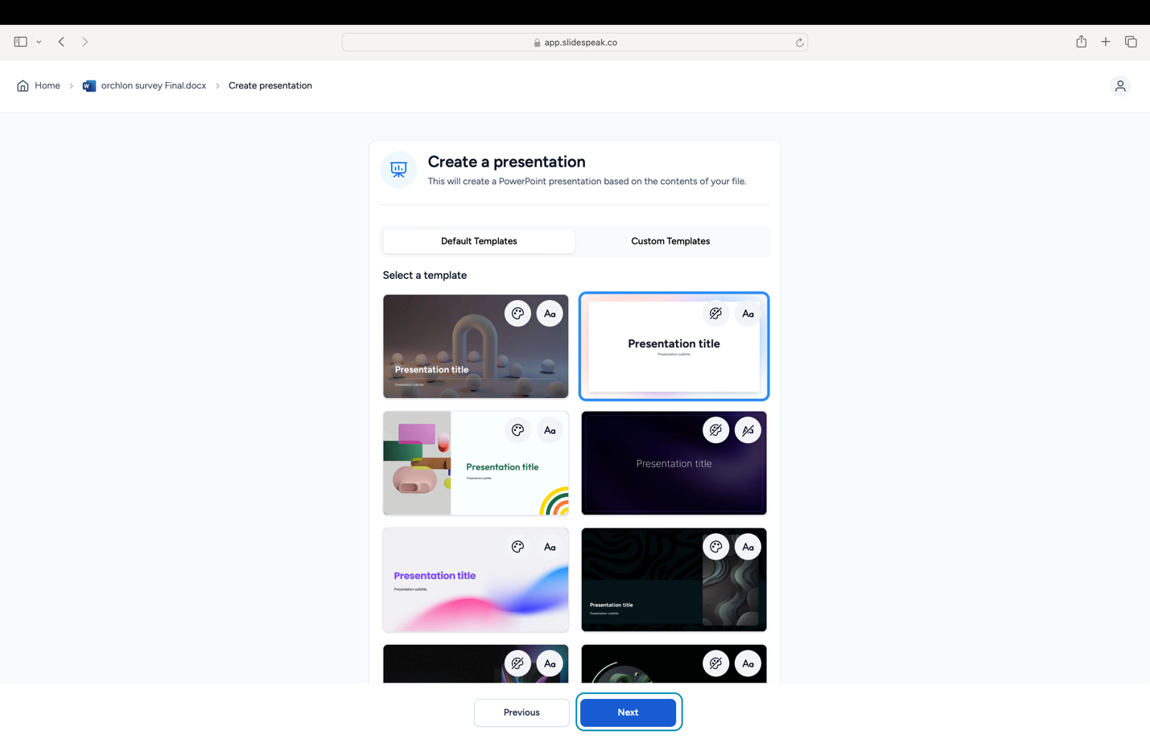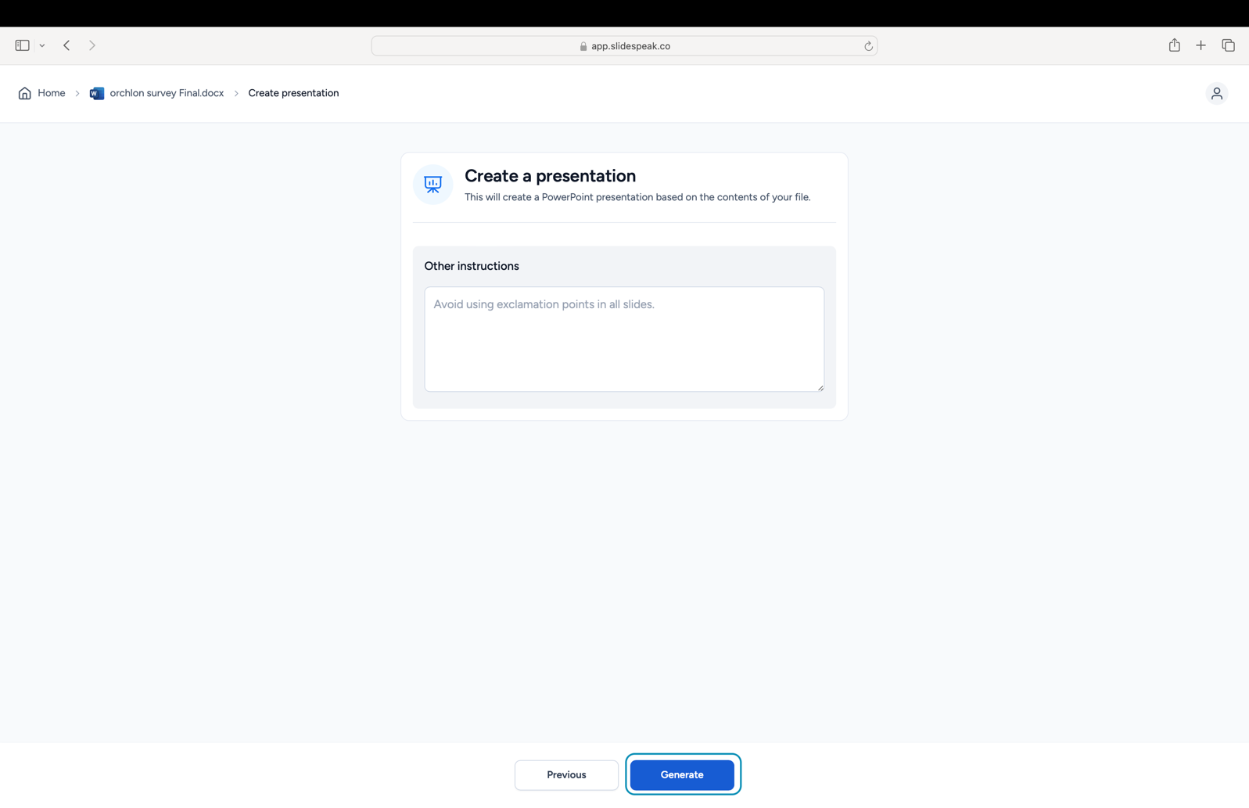

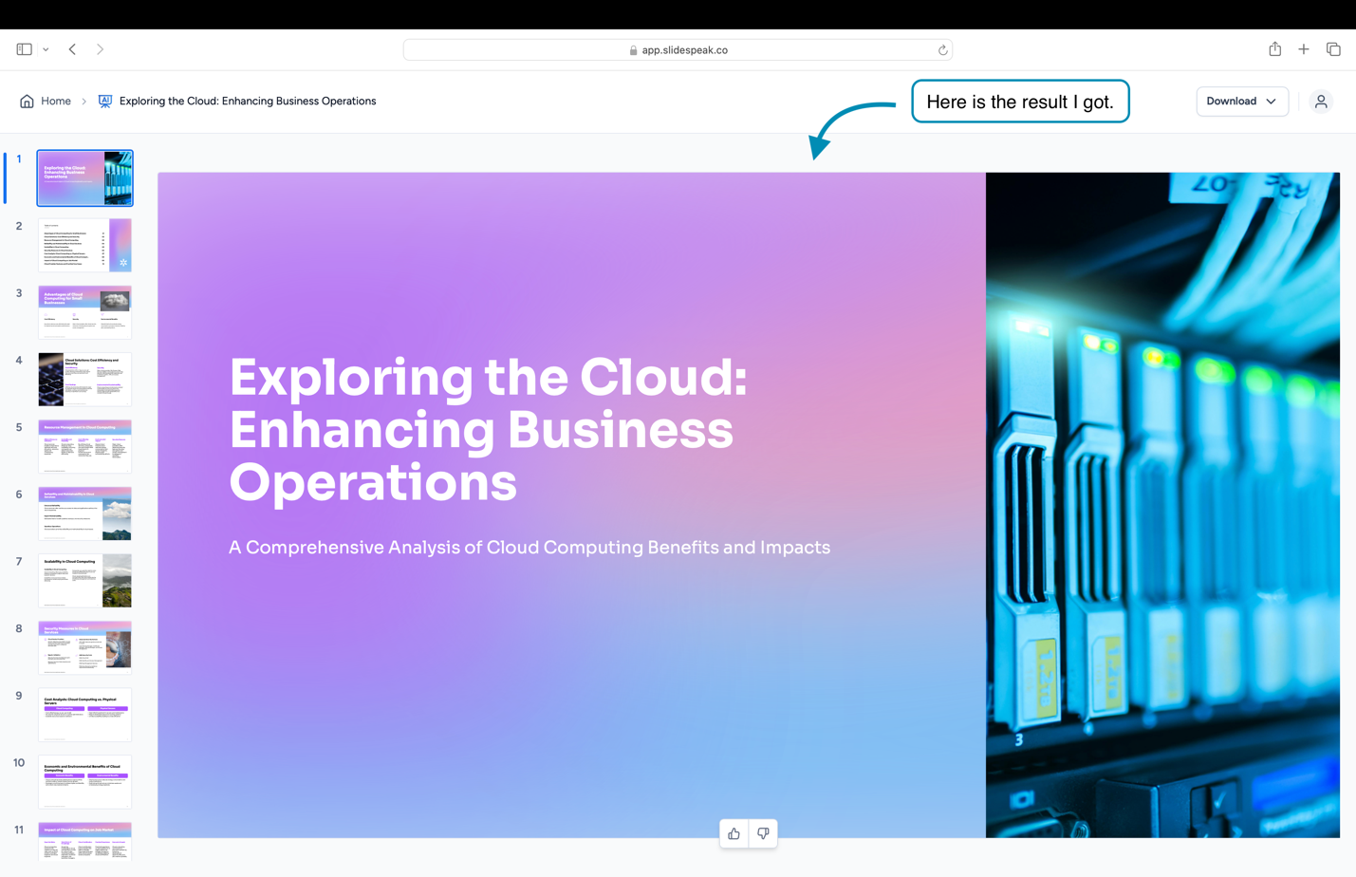

**URL:**

* [**https://app.slidespeak.co/presentation/cm4f8y27f001eodru3m8caaav/share**](https://app.slidespeak.co/presentation/cm4f8y27f001eodru3m8caaav/share)